"The Path to Peace in Israel/Palestine: A Jewish American’s Journey.”
May 2-3 with Dr. Mark Braverman
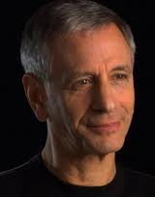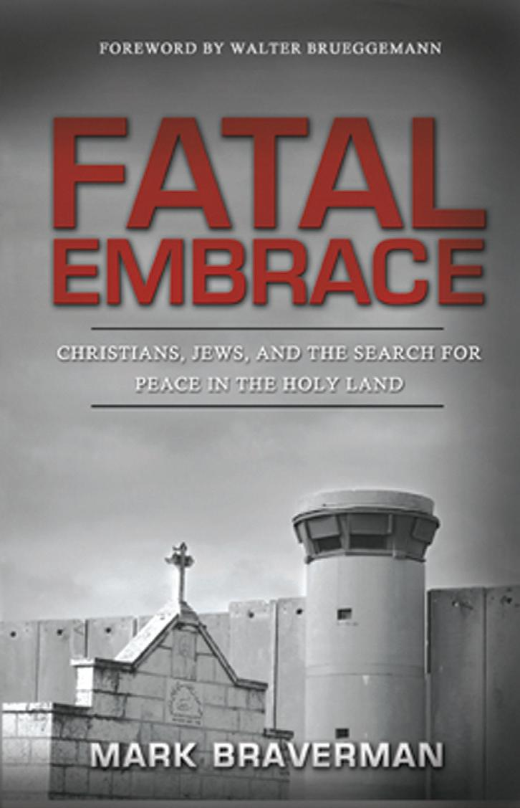
Monday, May 2nd
Presentation and Discussion at Congregation Nahalat Shalom, 3606 Rio Grande Blvd, NW, Albuquerque. For more info, call 343-8227
Topic: "When politics fail -- the grassroots movement that will bring peace to Israel/Palestine.”
Time: 7-9 pm.
Tuesday, May 3
Presentation and Discussion at UNM’s Aquinas Newman Center, 1815 Las Lomas Rd, NE, Albuquerque. For more info, call 247-1094
Topic: "The Path to Peace in Israel/Palestine: A Jewish American’s Journey.”
Time: 11am-1 pm.
Tuesday, May 3
Presentation and Discussion at Risen Savior Catholic Church, 7701 Wyoming Blvd., NE, Albuquerque. For more info, call 821-1571
Topic: “The Role of the Faith Communities in Achieving a Just Peace in the Holy Land.”
Time: 7 pm-9 pm.

SUGGESTED DONATION: $15 AT THE DOOR. NO ONE WILL BE TURNED AWAY FOR LACK OF FUNDS. FOR MORE INFORMATION, CALL 505-246-2231

